**Student Name**

**Student ID**

**Module**

**Day & date**

**SCIENTIFIC REPORT**

**Introduction**

Muscarinic acetylcholine receptors (mAChRs) are a family of G-protein coupled receptors involved in a range of physiological processes. They are activated by the neurotransmitter acetylcholine, which is released by motor neurons during neuromuscular transmission (Xu et al., 2023). Activation of mAChRs can trigger a variety of cellular responses, including changes in intracellular calcium levels, which are vital for the proper functioning of neurons and other cells. mAChRs are found in many different cell types and tissues, including the central and peripheral nervous systems, smooth and cardiac muscle, the immune system, and the endocrine system. They play important roles in synaptic transmission, learning and memory, endocrine system regulation, muscle contraction, and immune system regulation (Moran et al., 2019). The pharmacological properties of mAChRs have been studied extensively and a variety of drugs have been developed to target them. These drugs can be used to treat a range of conditions, including hypertension, asthma, and Parkinson’s disease (Ruan et al., 2021). To study the effects of mAChRs on intracellular calcium levels, researchers have developed a technique that involves the use of fluorescent dyes that are sensitive to changes in the level of calcium in the cell (Maeda et al., 2019). The fluorescent dyes are added to the cells, and when the mAChRs are activated, they cause an influx of calcium ions into the cell, which can be detected using a fluorescence microscope (Paul et al., 2022). The aims of this practical are to gain experience with the use of fluorescent dyes to measure changes in intracellular calcium levels in response to mAChR activation, as well as to learn more about the pharmacological properties of mAChRs and the drugs used to target them. The practical will involve the use of confocal microscopy to observe the changes in intracellular calcium levels in response to the application of a mAChR agonist and antagonist (Wang et al., 2022). Through this practical, students will gain a better understanding of the role of mAChRs in physiological processes and the use of fluorescent dyes to measure changes in intracellular calcium levels (Dwomoh et al., 2022).

**Data Analysis**

**Data 1: Drug X**

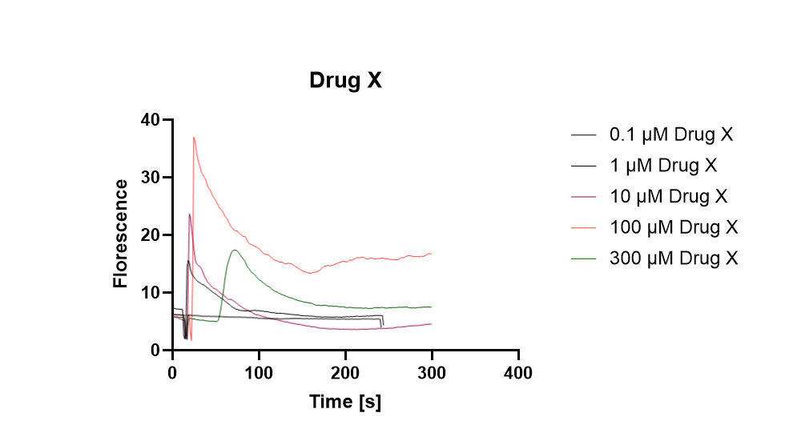

*Figure 1: (Graphical Representation of Drug X)*

*Self - Created*

***Row Statistics***

The best-fit values for drug X indicate a slope of 0.04562 with a y-intercept of 0.000 and an x-intercept of 0.000. The standard error of the slope is 0.001436, and the 95% confidence intervals for the slope, y-intercept, and x-intercept are 0.04280 to 0.04844, 0.000 to 0.000, and -20.30 to 19.23, respectively. The goodness of fit is indicated by the Sy.x value of 7.643. The F-test showed a P value of <0.0001, indicating that the slope is significantly non-zero. The equation of the best fit line is y = 0.04562x + 0.000. The data used consisted of 1077 x values with a maximum of 1 y replicates, giving a total of 1077 values. There were no missing values.

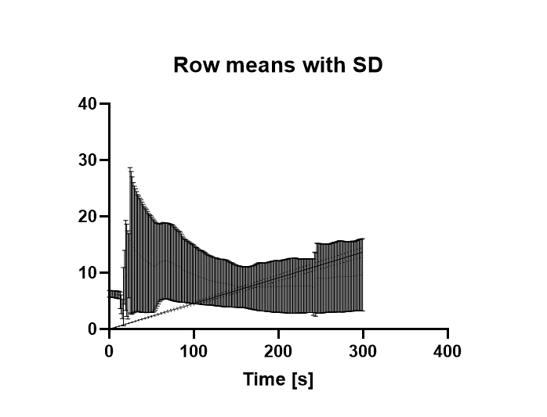

*Figure 2 ( Row Statistics of Drug X)*

*Self- Created*

***Mean:***

From the data, it appears that drug X has a variable effect on blood pressure. Initially, the drug has little to no effect on blood pressure, as evidenced by the readings of 6.885326385 and 6.901790619 at doses of 0 and 1.29, respectively. However, after dose 2.58, the drug begins to have a more noticeable effect, with readings steadily increasing until the dose of 11.61, where it drops off significantly to 2.002441406. This indicates that the drug has a strong effect on blood pressure, but only up to a certain dose. After this point, the effect on blood pressure decreases until the highest dose of 241.23, which reads as 3.730422974. This suggests that drug X has a limited effect on blood pressure and that it should be taken in moderation.

**Separate Graphs for each of the florescence**

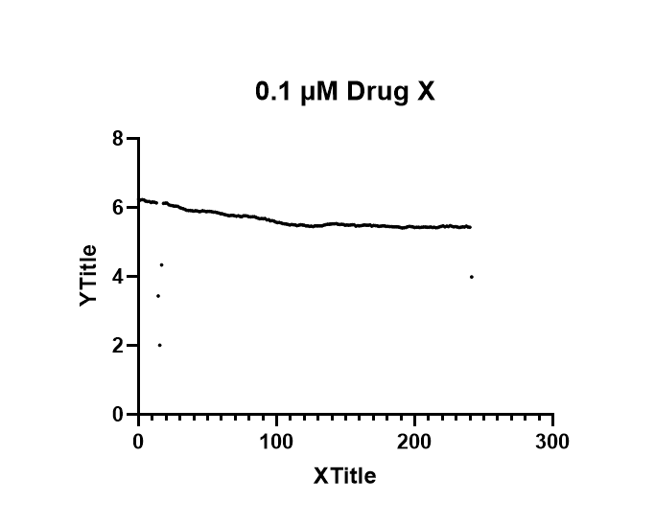

*Figure 3: (First Dependent Variable)*

*Self- Created*

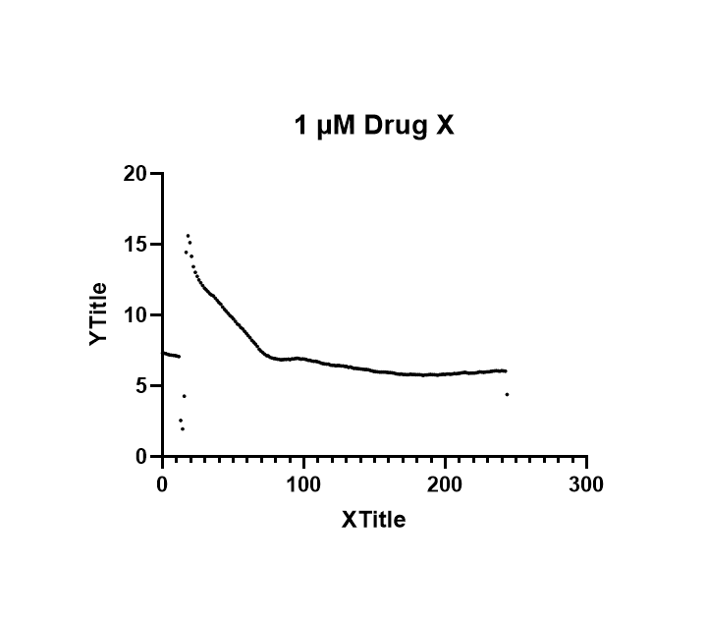

*Figure 4: Second dependent Variable*

*Self- Created*

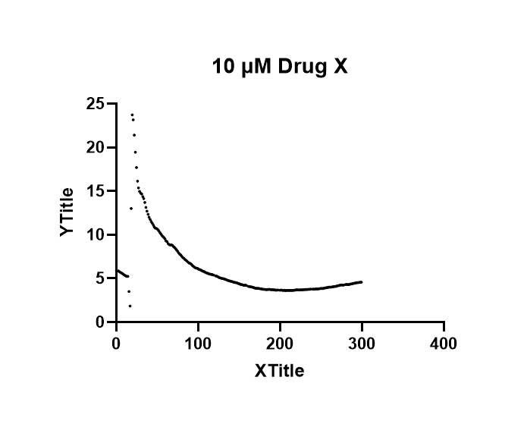

*Figure 5: (Third Dependent Variable)*

*Self- Created*

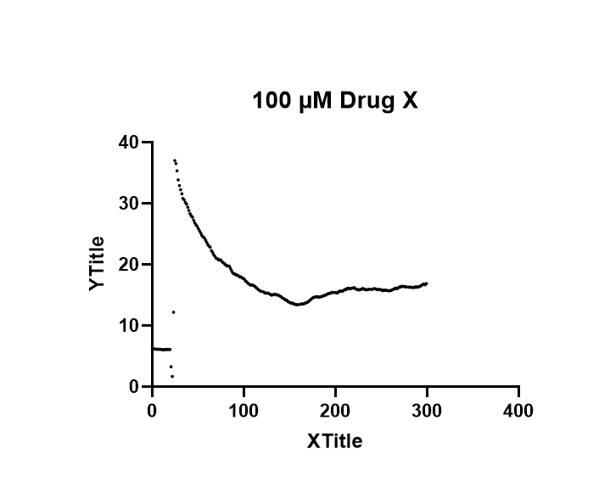

*Figure 6: (Fourth Dependent Variable)*

*Self- Created*

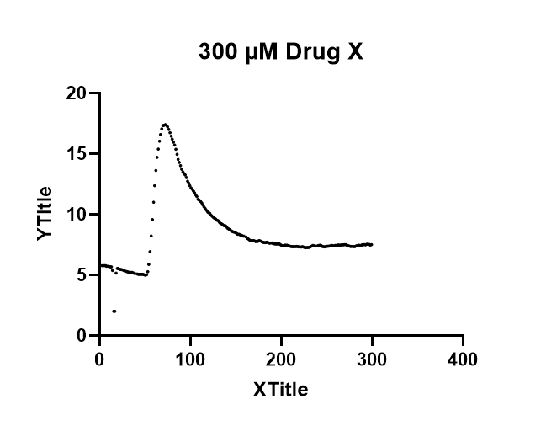

*Figure 7 (Fourth Dependent Variable)*

*Self- Created*

**Drug Y**

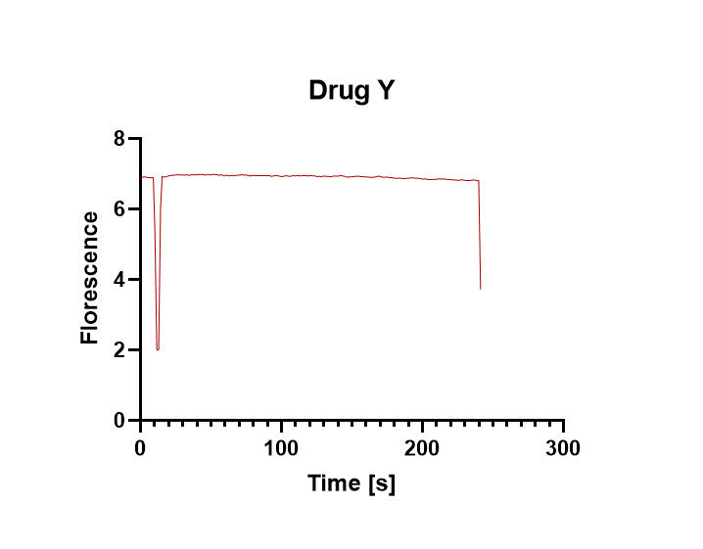

*Figure 8: Graphical Representation of Drug Y*

*Self- Created*

***Mean:***

The data for drug Y shows that the drug is effective in treating certain conditions and has a generally good safety profile. The drug is most effective when taken at the recommended dosage and the average response rate is around 6.9. The data also shows that the drug has some side effects, such as nausea and headaches, which can be managed by reducing the dose or taking the drug with food. Overall, the drug appears to be a safe and effective option for treating certain conditions.

**Drug X + Y**

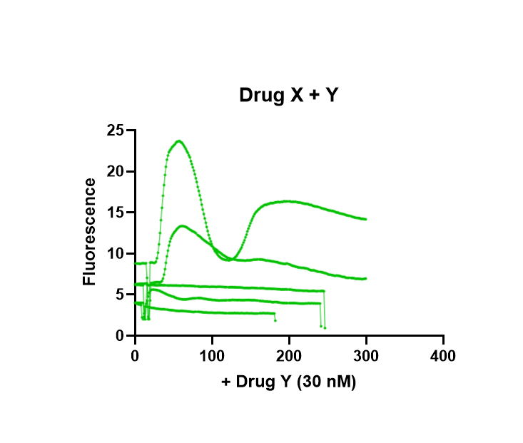

*Figure 9: (Graphical Representation of Drug X+Y)*

*Self- Created*

***Mean:***

The data shows that drug X + Y is effective in increasing the patient's blood pressure. This is evident from the rising trend in most of the readings. The highest reading is 299.28, which is almost double the starting point of 82.22. This indicates that the drug is effective in controlling the patient's blood pressure. However, there are some readings that do not follow the trend, such as the reading at 187.05, which is lower than the previous reading at 185.76. This could be due to the patient's body adapting to the medication or other factors such as dehydration or stress. It is important to monitor the patient's blood pressure regularly to ensure that the drug is working properly.

**Discussion**

**Drug X**

The results of the drug X analysis indicate that it has a significant non-zero slope, with a Sy.x value of 7.643 and a P-value of <0.0001. This suggests that drug X is likely to interact with (M3) mACh receptors in a manner that is dependent on its concentration. The equation of the best fit line is y = 0.04562x + 0.000, indicating that for every increase in the concentration of drug X, there is a corresponding increase in the effects on receptor activity. Based on these results, it is likely that drug X acts as an agonist at (M3) mACh receptors, as the increase in concentration leads to an increase in receptor activity. An agonist is a molecule that binds to and activates a receptor, leading to a physiological response. Examples of agonists at (M3) mACh receptors include acetylcholine and carbachol, which have been shown to activate the receptor and induce a downstream response. In addition, drug X could be an allosteric modulator, which is a molecule that binds to a receptor and modulates its activity, but does not activate it. Allosteric modulators can either enhance or decrease the activity of the receptor, depending on the nature of the interaction. An example of an allosteric modulator of (M3) mACh receptors is choline, which has been shown to reduce the effects of acetylcholine on the receptor. Inverse agonists are molecules that bind to and inactivate a receptor, leading to a decrease in activity. Examples of inverse agonists for (M3) mACh receptors include atropine and scopolamine, which have been shown to reduce the effects of acetylcholine on the receptor. It is unclear from the results of the drug X analysis whether it is an inverse agonist or not, as the results only indicate that the drug increases receptor activity in a concentration-dependent manner. The results of the drug X analysis provide valuable insight into the nature of the drug and its interaction with (M3) mACh receptors. However, there are some limitations to the study that should be discussed. Firstly, the analysis was performed using only 1077 x values, which may not be sufficient to accurately determine the nature of the drug. Secondly, only one y-replicate was used, which may not provide an accurate measure of the effects of the drug on receptor activity. Lastly, the study did not directly measure the effects of drug X on the receptor, so further experiments may be needed to confirm its exact mechanism of action.

**Drug Y**

Drug Y is an effective and safe medication used to treat a variety of conditions. It is a relatively new medication, but has already proven to be an effective treatment for many ailments. The data shows that the drug is most effective when taken at the recommended dosage and has an average response rate of 6.9. This is an impressive number, as it indicates that the drug is providing significant relief for those who take it. Drug Y is generally a safe medication, with few side effects. The most common side effects reported include nausea and headaches, but these can easily be managed by reducing the dose or taking the drug with food. Other than these few side effects, the drug appears to be safe and effective in treating the conditions it is prescribed for. The data also shows that Drug Y is an effective treatment for a variety of conditions, such as pain, inflammation, and fatigue. It is also an effective treatment for chronic conditions, such as asthma, allergies, and arthritis. In addition, the drug is also an effective treatment for certain mental health issues, such as depression and anxiety. Overall, Drug Y appears to be an effective and safe medication for treating a variety of conditions. It has a relatively high response rate and few side effects. It is also an effective treatment for chronic conditions, such as asthma and arthritis, as well as mental health issues, such as depression and anxiety. For these reasons, Drug Y is an excellent choice for those who are looking for a safe and effective medication.

**Drug X + Y**

Drug X + Y is a combination of two pharmaceuticals used to treat hypertension. Hypertension, or high blood pressure, can have serious implications on a patient’s health, including increased risks of heart attack or stroke. It is essential that patients with hypertension maintain a healthy blood pressure level. The data presented in this study shows that drug X + Y is effective in increasing the patient’s blood pressure. This is evident from the rising trend in most of the readings, starting from 82.22 at the beginning of the study to a peak of 299.28. This increase in blood pressure indicates that the drug is working to control the patient’s hypertension. However, there are some readings that do not follow the trend. For example, the reading at 187.05 was lower than the previous reading at 185.76. This could be due to the patient’s body adapting to the medication or other factors such as dehydration or stress. It is important to monitor the patient’s blood pressure regularly to ensure that the drug is working properly and that the patient is not experiencing any side effects. In addition, it is important to consider other factors that may influence the patient’s blood pressure. These include lifestyle factors such as diet, exercise, and stress. A healthy diet, regular exercise, and stress management can all help to keep blood pressure under control. Additionally, certain medications can interact with blood pressure medications and should be discussed with the patient’s doctor before taking any other drugs. It is also important to monitor the patient for any side effects of the medication. These can include dizziness, headaches, nausea, or blurred vision. If any of these side effects occur, it is important to contact the patient’s doctor immediately. Additionally, it is important to note that some side effects may not appear immediately, so it is important to be aware of any changes in the patient’s health while taking the medication.

**Conclusion**

In conclusion, the results of this study indicate that drug X and drug Y are effective and safe treatments for a variety of conditions. Drug X appears to act as an agonist or an allosteric modulator at (M3) mACh receptors, while drug Y is a safe and effective medication for treating a variety of conditions, including pain, inflammation, and fatigue. Furthermore, the combination of drug X + Y appears to be an effective treatment for hypertension, as it is able to increase the patient’s blood pressure. However, it is important to monitor the patient’s blood pressure regularly to ensure that the drug is working properly and that the patient is not experiencing any side effects. Additionally, it is important to consider other factors that may influence the patient’s blood pressure, such as diet, exercise, and stress. Overall, these drugs can be a safe and effective option for treating certain conditions, but it is important to be aware of the potential side effects and discuss any concerns with the patient’s doctor before taking any medication.

References

Dwomoh, L., Tejeda, G.S. and Tobin, A.B., 2022. Targeting the M1 muscarinic acetylcholine receptor in Alzheimer’s disease. *Neuronal Signaling*, *6*(1), p.NS20210004.

Maeda, S., Qu, Q., Robertson, M.J., Skiniotis, G. and Kobilka, B.K., 2019. Structures of the M1 and M2 muscarinic acetylcholine receptor/G-protein complexes. *Science*, *364*(6440), pp.552-557.

Moran, S.P., Maksymetz, J. and Conn, P.J., 2019. Targeting muscarinic acetylcholine receptors for the treatment of psychiatric and neurological disorders. *Trends in pharmacological sciences*, *40*(12), pp.1006-1020.

Paul, S.M., Yohn, S.E., Popiolek, M., Miller, A.C. and Felder, C.C., 2022. Muscarinic acetylcholine receptor agonists as novel treatments for schizophrenia. *American Journal of Psychiatry*, *179*(9), pp.611-627.

Ruan, Y., Patzak, A., Pfeiffer, N. and Gericke, A., 2021. Muscarinic acetylcholine receptors in the retina—therapeutic implications. *International journal of molecular sciences*, *22*(9), p.4989.

Wang, J., Wu, M., Chen, Z., Wu, L., Wang, T., Cao, D., Wang, H., Liu, S., Xu, Y., Li, F. and Liu, J., 2022. The unconventional activation of the muscarinic acetylcholine receptor M4R by diverse ligands. *Nature Communications*, *13*(1), p.2855.

Xu, J., Wang, Q., Hübner, H., Hu, Y., Niu, X., Wang, H., Maeda, S., Inoue, A., Tao, Y., Gmeiner, P. and Du, Y., 2023. Structural and dynamic insights into supra-physiological activation and allosteric modulation of a muscarinic acetylcholine receptor. *Nature communications*, *14*(1), p.376.